Task 4

1.How to compare two JSON have the same properties without order?

* 1. var obj1 = { name: "Person 1", age:5 };
  2. var obj2 = { age:5, name: "Person 1" };

Program :

var obj1 = { name: "Person 1", age:5 };

var obj2 = { age:5, name: "Person 1" };

JSON.stringify(obj1) === JSON.stringify(obj2);

// true

console.log("true");

Output:

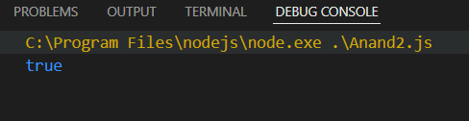

2.Use the rest countries API url -><https://restcountries.eu/rest/v2/all> and display all the country flags in console

Program:

let request = new XMLHttpRequest();

request.open('GET', 'https://restcountries.com/v3.1/all/flags');

request.send();

request.onload = function() {

    if (request.status == 200) {

        console.log(request.responseText);

    }else

    {

        console.error('request not success');

    }

};

request.onerror = function() {

    console.error('request error');

};

Output:

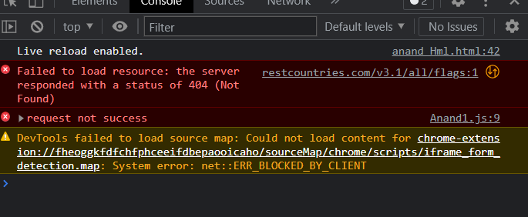

Because there is no flags in the API so that it showing error.

3.Use the same rest countries and print all countries name, region, sub region and population

Program:

let request = new XMLHttpRequest();

request.open('GET', 'https://restcountries.com/v3.1/all');

request.send();

request.onload = function() {

    if (request.status == 200) {

        console.log(request.responseText);

    }else

    {

        console.error('request not success');

    }

};

request.onerror = function() {

    console.error('request error');

};

Output:

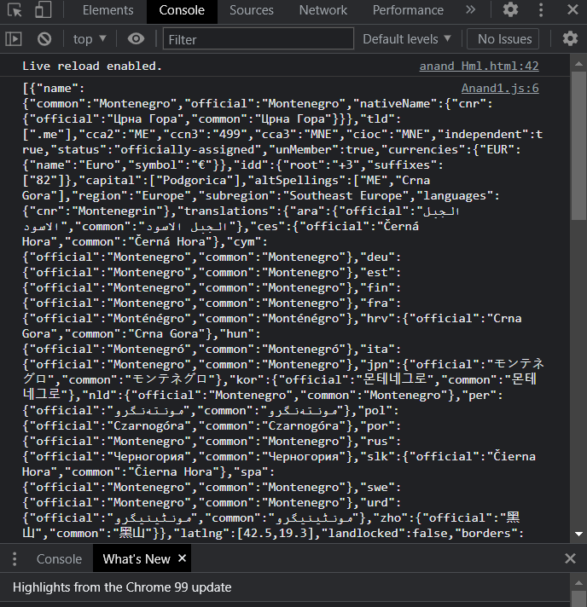

Instead of “All” we use name, region, subregion. We got the output but population there is no data will be available so that we got only request error.

For name URL: <https://restcountries.com/v3.1/name>

For Region URL: <https://restcountries.com/v3.1/region>

For SubRegion URL: <https://restcountries.com/v3.1/subregion>